Date of sale: ____________________________________

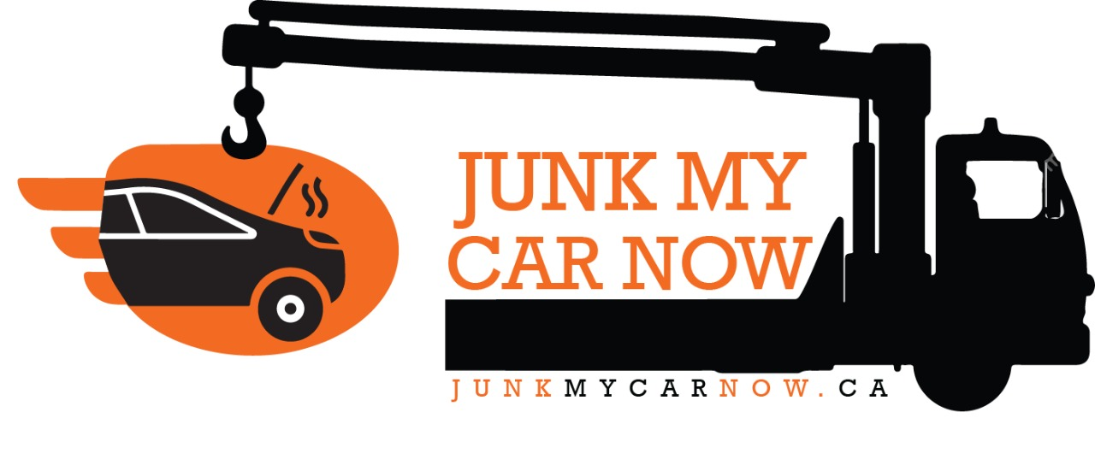
BILL OF SALE

I, (seller name) _____________________________________________________

of (seller address) ___________________________________________________

do sell (year, make and model of vehicle) ________________________________

the VIN number is __________________________________________________

I am selling this vehicle to Junk My Car Now Ltd. for (amount) $_____________

Seller Name: ____________________________________

Buyer Name: ____________________________________

To be handed to tow truck driver at point of pick up and exchange of monies.

